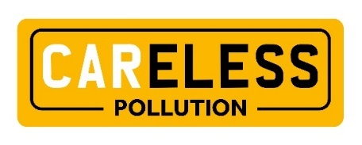

IDEAS FOR ACTION

Whether you are a local resident who is concerned about the health impacts of air pollution from idling vehicle engines in your street, a local employee who is keen to see your company take positive action locally, or an experienced environmental campaigner tackling climate change, this volunteer pack is here to provide ideas for action on how we can all help improve the air that we breathe in Colchester.

Any help you can offer, however small, is appreciated – we are stronger when we work together. There are a range of ways to provide support, for example, distributing postcards to neighbours and displaying a poster in your window or giving a talk at your local community centre or workplace.

One of the most effective actions is to encourage the people you know, or come in contact with during the course of your day, to switch off their vehicle engines every time they wait. This is because idling car engines are one of the most significant causes of air pollution, contributing up to 30%.

That’s why we hope you will join us to raise awareness of the CAReless Pollution campaign across Colchester.

We have listed a range of ideas below. This is not an exhaustive list, so please get in touch if you have any other ideas – we would love to hear from you, and we can then share your ideas with other volunteers.

To request supplies of FREE CAReless Pollution campaign materials such as postcards, posters or banner stands please email cleanair@colchester.gov.uk.
Electronic versions of campaign materials can all be viewed and downloaded from www.cleanaircolchester.org

Promotion in your local community

Outdoor signs: If you live in an area where people frequently sit in their vehicles with the engine idling, for example at traffic lights, or while waiting to pick up a child from school, then please consider putting up one of our ‘switch off your engine every time you wait’ weatherproof board on your fence outdoors, or a poster at your window. Our research shows that idling is an inadvertent action and that visual reminders to switch off the engine can be very effective.

Posters: Our campaign posters can be displayed on community hall notice boards or in other places where people gather for meetings or activities. We have two different designs of poster to suit a home or community setting, one with a simple ‘switch off while you wait’ message that can easily be read from a distance, and the other one with a ‘take care of your air’ message designed to be read close up.

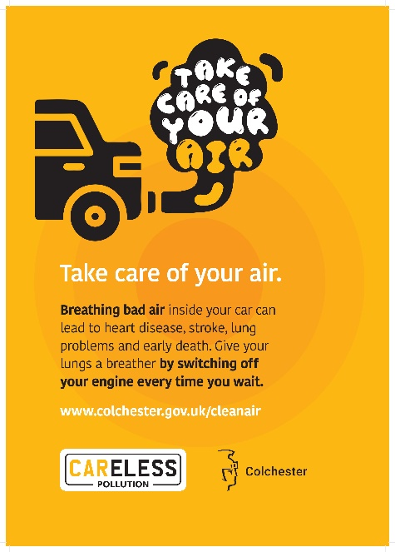

Postcards: We have postcards with a simple ‘switch off while you wait’ message on the front and myths & facts on the reverse. Distributing the postcards in your neighbours is a great way to raise awareness of the campaign locally.

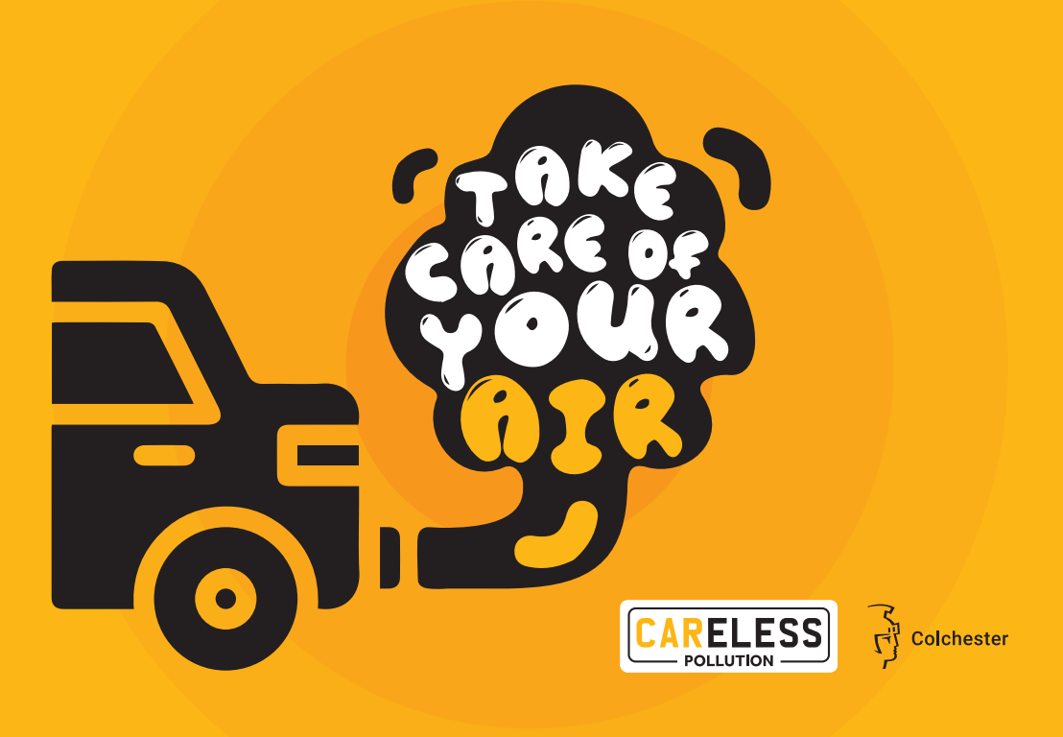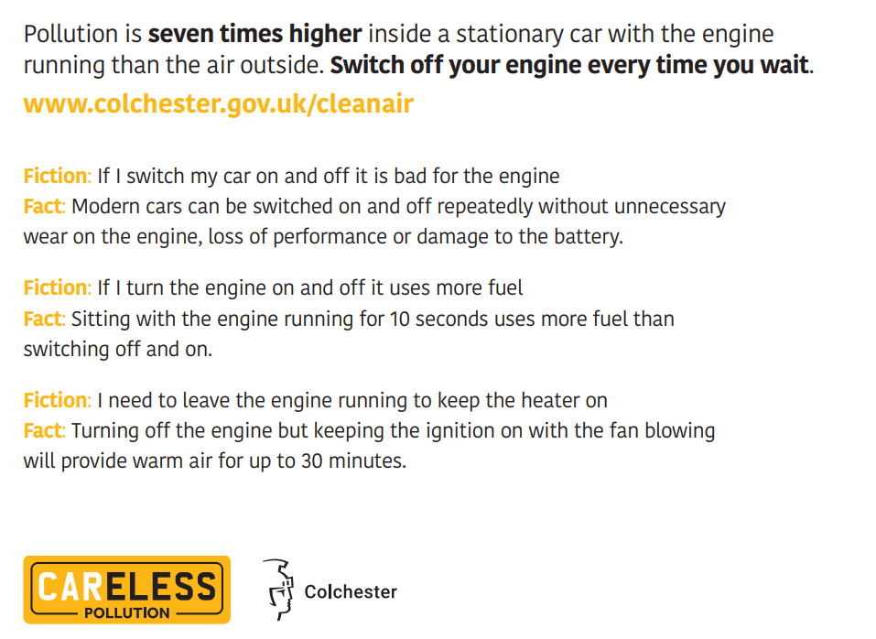

Article in your local community newsletter: Many local communities, Resident’s Associations or Parish Councils have a monthly newsletter which is distributed widely within the local community and well read. Consider contacting the person who edits the newsletter and ask if you can place an article to raise awareness of air pollution and simple actions that local residents can take. We have produced some template copy in the pack which you can adapt to make relevant to your local area.

Social media posts on your local Facebook group: If your local community or Resident’s Association has a Facebook group then posting regular updates is a simple way to raise awareness and let local residents know where they can access materials. We have provided some template copy to get you started but please feel free to amend this and make it relevant to your local area. Your local Councillor may be able to help too.

Campaign tools available to support you:
- Outdoors weatherproof boards A3 or A4 sized: ‘Switch off your engine every time you wait’
- Posters A4 sized: one with a simple ‘switch off while you wait’ message that can easily be read from a distance, and the other one with a ‘take care of your air’ message designed to be read close up
- Postcards A6 sized
- Template newsletter text
- Template social media posts
- Myths and facts

Promotion in your workplace

Presentation: Do you work for a local company or organisation? Can you make an opportunity to start a conversation about air pollution, particularly if staff members drive to work. Could you give a presentation at a team meeting? Or a lunchtime talk or webinar? You could use the presentation for this or play our short campaign film. Improving sustainability and reducing environmental impact are very much at the forefront of business thinking right now, so supporting a local campaign to improve air quality is one easy way for your employer to fulfil their Corporate Social Responsibility commitments and reduce their carbon emissions.

Posters: If your workplace has a reception area, staff canteen/tea room, meeting rooms, or toilets, then please consider putting up one of our campaign posters.

Electronic communication: Could you get the campaign information uploaded onto your company intranet or shared electronic files? Is there an opportunity to include it in a company e-newsletter or do a themed email using the template text information included in this pack. The text can also be presented as a news style piece or as a social media post.

Campaign tools available to support you:
- Short 8 minute narrated presentation
- Campaign film
- Posters to display in shared spaces
- Postcards to hand out to colleagues
- Template text for newsletters or website
- Social media posts for Facebook, Twitter or LinkedIn

Promotion at your local school

Toolkit for Schools: Our Toolkit for Schools is a comprehensive pack of information and activities aimed at primary and secondary school pupils in Colchester. Launched originally in 2021, it has already been well received by many local teachers but we need your help to ensure schools continue to use this resource as pupils move through the school, entering a new key stage.

Assembly: If you live near a school, or your children/grandchildren attend a local primary or secondary school, then could you speak to the Head or other senior teachers and ask if they would be willing to allow you to go into the school to talk about air pollution. Giving an assembly on the topic and setting out how we can all do our bit to help improve air quality is an ideal way to introduce this subject to school pupils. You could also ask if campaign posters can be put up in shared spaces and outdoor signs placed on the railings outside school and in areas where parents frequently idle engines at pick up or drop off.

Materials for school bags: We have postcards that can be sent home with pupils in their bookbags with a simple ‘switch off while you wait’ message on the front and myths & facts on the reverse. Children can add their own message to the postcards and distribute them to the adults that they know who drive a vehicle.

Electronic communication: We have template text that can be supplied to schools for them to include in the school’s electronic newsletter or in social media posts.

Campaign tools available to support you:
- Assembly presentation and short film from the Toolkit for Schools
- Posters to put up in the school hall and reception area
- Postcards to hand out to pupils
- Outdoor signs for areas where parents drop off or pick up
- Banner stand to use when giving an assembly
- Template text for newsletters or website
- Social media posts for Facebook, Twitter or Instagram

Engaging in conversations with drivers

You may wish to approach drivers in their vehicles when they are sitting idling and politely let them know the consequences of keeping their engines running. By being friendly and positive you’re likely to find that lots of people are interested in what you have to say Research shows that idling is an inadvertent habit for most drivers, and not a conscious choice, so once people understand the problem of air pollution they are willing to switch off. However, some people simply won’t want to listen or change their behaviour. Don’t push people if they seem uninterested. Ultimately your safety is paramount so if you feel that someone is being aggressive then please walk away.

Campaign tools available to support you:
- Hi-vis vest
- Sample dialogue (see below)
- Postcards to hand out
- Car hangers to hand out

Here is an example dialogue if you approach someone with their engine on:
- “Hello – we are supporting a local campaign asking you and other drivers to switch off the engine while you wait to improve your own health and local air quality.”
- You might then want to say, “Did you know that air pollution inside a stationary car with the engine running is seven times higher than the air outside.”
- We hope at this point that they switch off their engine. You should offer them a postcard to take away
- If they give an excuse for idling then our myths and facts in this pack should help you answer
- If they don’t switch off their engine then end the conversation politely and walk away

Top tips to remember if you are approaching drivers, particularly those queuing at traffic lights
- Always stand on the kerb side and away from moving traffic. Never go on the road
- Cross all roads safely, stick to normal pedestrian safety rules and take a break if you feel unwell or tired
- Try to take someone with you rather than approaching drivers on your own
- Wear a hi-vis vest to make sure drivers and other road users can see you
- Be non-confrontational at all times. Approach vehicles tentatively, speak in a calm tone of voice and be polite. Don’t knock on windows, but wave at drivers. Don’t write down any registration details or be authoritarian. Nobody likes being told what to do – always ask rather than instruct
- Walk away if a driver doesn’t want to engage with you
- Be aware that some drivers may act aggressively. If they seem angry or aggressive then don’t carry on trying to talk to them and walk away
- Please be aware of your own exposure to air pollution. Take any necessary precautions to make sure you don’t put yourself in a vulnerable situation

